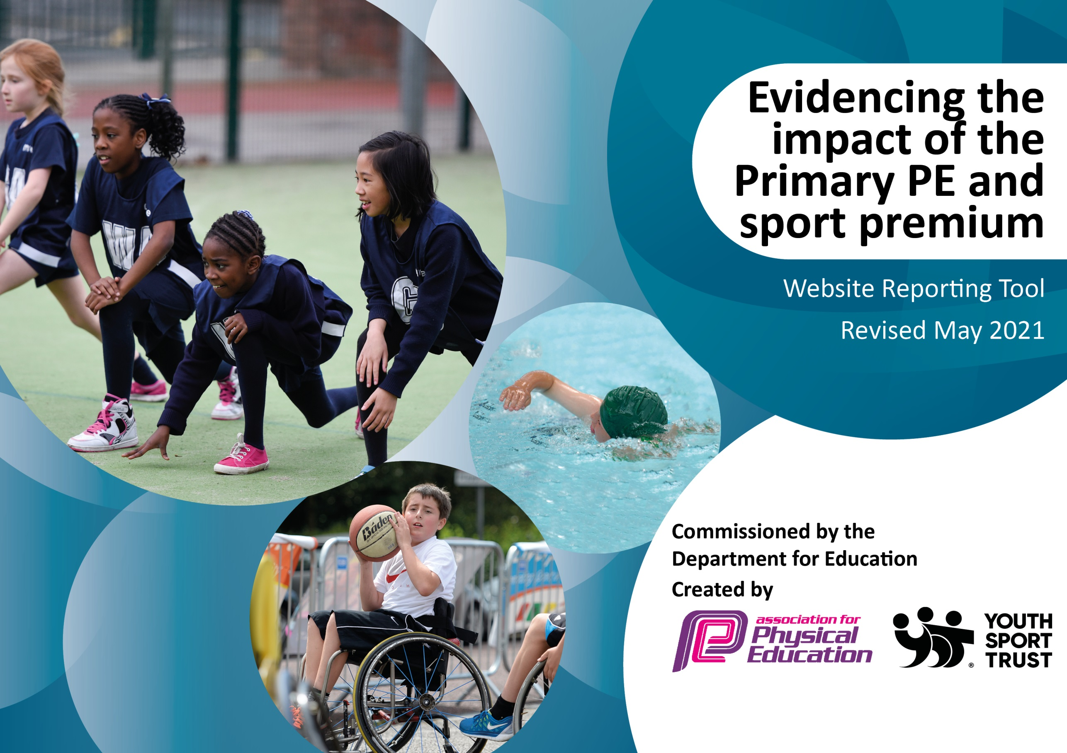

It is important that your grant is used effectively and based on school need. The Education Inspection Framework (Ofsted 2019 p64) makes clear there will be a focus on ‘whether leaders and those responsible for governors all understand their respective roles and perform these in a way that enhances the effectiveness of the school’.

Under the Quality of Education criteria (p41) inspectors consider the extent to which schools can articulate their curriculum (INTENT), construct their curriculum (IMPLEMENTATION) and demonstrate the outcomes which result (IMPACT).

To assist schools with common transferable language this template has been developed to utilise the same three headings which should make your plans easily transferable between working documents.

Schools must use the funding to make additional and sustainable improvements to the quality of Physical Education, School Sport and Physical Activity (PESSPA) they offer. This means that you should use the Primary PE and sport premium to:

- Develop or add to the PESSPA activities that your school already offer
- Build capacity and capability within the school to ensure that improvements made now will benefit pupils joining the school in future years
- The Primary PE and sport premium should not be used to fund capital spend projects; the school’s budget should fund these.
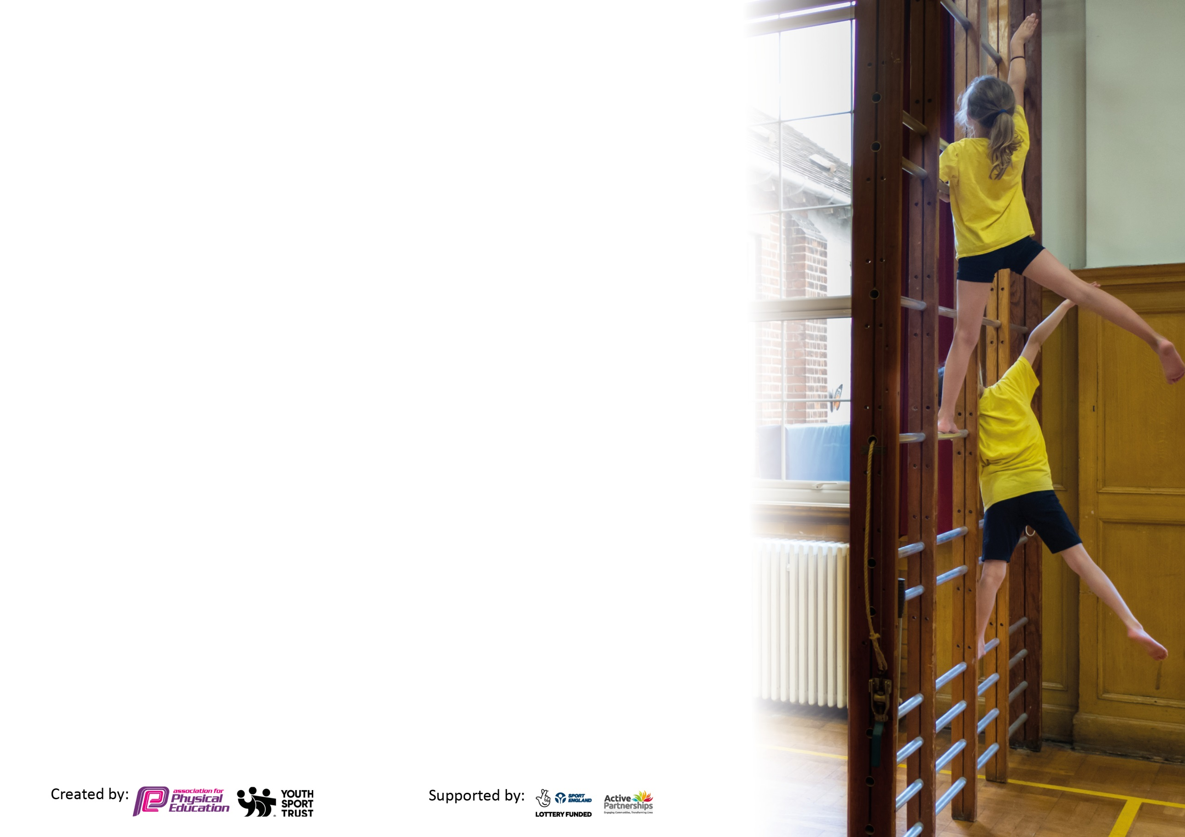
Please visit gov.uk for the revised DfE guidance including the 5 key indicators across which schools should demonstrate an improvement. This document will help you to review your provision and to report your spend. DfE encourages schools to use this template as an effective way of meeting the reporting requirements of the Primary PE and sport premium.

We recommend you start by reflecting on the impact of current provision and reviewing the previous spend.

Schools are required to publish details of how they spend this funding, including any under-spend from 2019/2020, as well as on the impact it has on pupils’ PE and sport participation and attainment by the end of the summer term or by 31st July 2022 at the latest.

We recommend regularly updating the table and publishing it on your website throughout the year. This evidences your ongoing self-evaluation of how you are using the funding to secure maximum, sustainable impact. Final copy must be posted on your website by the end of the academic year and no later than the 31st July 2021. To see an example of how to complete the table please click HERE.

Key achievements to date until July 2023: | Areas for further improvement and baseline evidence of need:
School after school clubs expanded and open all school year. We held 26 different after school clubs with attendance was good with most clubs reaching their capacity on within weeks of sign ups going live.  We opened up our range of activities on offer to try and reach those who do not already participate. These clubs included dodgeball. Benchball, dance/cheerleading and circus skills. Our PE TA was used for some of these clubs and also IG sports a local coaching company.  Nearly 40 fixtures/festivals took place involving Selwood pupils. These were over all the age groups and levels of ability. National and regional competitions were entered.  They included football/rugby/netball/hockey/dodgeball/indoor and outdoor athletics/cricket/cross country. Pupils were also traveling to schools they had not played before learning from different areas rather than just playing the same schools. Our PE TA was present for most of these as our first aider and also our second member of staff.  The school entered the mini London Marathon where every pupil in the school took part in running/jogging/walking a mile in an attempt to break a world record. Although we didn’t break the record it was a highlight of the year for some pupils as their best achievement when I took student voice at the end of the school year. This was great to help the school come together as a community.  Year 5 had a caving and team building experience. For the first time all students were invited to take part and experienced the caves. This was part subsidised as a trip to ensure that all pupils had the chance for the experience.  Year 6 camp – This year we managed to open this trip up to all students in the year group. Last year it was only for the first 80 students who applied, meaning that some may have missed out. This year we took 96 pupils to a residential camp for 3 days/2 nights taking part in a number of OAA activities.  Sports Day – We held a whole school sports day which enabled parents to attend for the whole day. All pupils were involved with inclusive activities mixed with competitive ones. Medals were purchased for all competitive events as well as certificates given to anyone who participated in an event and finished in the top 3 places.  Lunch time 3G club – Hired a coach to take football on the 3G each lunchtime to enable pupils to have a healthy active lunch time.  Bath Rugby coaching – Held 5 sessions with Bath rugby coming into our school to encourage and develop girls interested in rugby. This also acted as a CPD session for members of staff.  Team bath Netball trip – Organised a trip for the netball teams to attend a Team bath game. This was subsidised to those who had represented the school at netball.  Interform events – We held two main interform days where the whole school participated in three activities against other tutor groups in a competitive interschool competition. Scores were kept and added up after sports day when a final winner was announced. This is encouraged as part of a competitive opportunity for all as part of a PE curriculum.  Careers boards in changing rooms – We have displayed and advertised a number of different careers linked to PE. These are a good talking point when pupils are getting changed, especially as they have all the details of all the jobs on including their wages.  Crazy catches purchased – We purchased three crazy catches to enable us to play some alternative games, and also improve hand eye coordination in a fun way.  Rugby posts – We have purchased rugby posts for our rugby pitch to enable us to expand our rugby players skills and knowledge of the game. This also future proofs our facility and will enable us to play full rugby matches in year 8/9 if we want to. | Establish, recruit and train PE Prefects/Sports Leaders to support lunchtime staff in leading lunchtime activities for lunchtime provision to expand successfully, this is to include a lunch time football league, and a girls only session on the 3G.  Use TA to take break out groups during lessons to improve the progress of our SEND and other pupils who struggle in PE.  Create a new concept based curriculum with head, hands heart assessment model to enable us to engage all pupils into why PE, physical activity and wellbeing is important.  Increase the range of after school sports further by using specialist training in fencing and basketball and dance as these are some activities raised in our student voice.  To increase links with community clubs by linking on our website and social media feeds.  Look into the possibility of teaching basic lifesaving skills and first aid.  Look into road and bike safety courses to be taught.

Meeting national curriculum requirements for swimming and water safety.

What percentage of your current Year 6 cohort swim competently, confidently and proficiently over a distance of at least 25 metres?  N.B. Even though your pupils may swim in another year please report on their attainment on leaving primary school at the end of the summer term 2021.  Please see note above. | 75%
What percentage of your current Year 6 cohort use a range of strokes effectively [for example, front crawl, backstroke and breaststroke]?  Please see note above. | 50%
What percentage of your current Year 6 cohort perform safe self-rescue in different water-based situations? | 21%
Schools can choose to use the Primary PE and sport premium to provide additional provision for swimming but this must be for activity over and above the national curriculum requirements. Have you used it in this way? | Yes - £2164

Action Plan and Budget Tracking
Capture your intended annual spend against the 5 key indicators. Clarify the success criteria and evidence of impact that you intend to measure to evaluate for pupils today and for the future.

Academic Year: 2022/23 | Total fund allocated: £ 24,158 | Date Updated: 30/7/23
Key indicator 1: The engagement of all pupils in regular physical activity – Chief Medical Officers guidelines recommend that primary school pupils undertake at least 30 minutes of physical activity a day in school |  |  |  | Percentage of total allocation:
 |  |  |  | 48%
Intent | Implementation |  | Impact
Your school focus should be clear what you want the pupils to know and be able to do and about  what they need to learn and to  consolidate through practice: | Make sure your actions to achieve are linked to your intentions: | Funding allocated: | Evidence of impact: what do pupils now know and what can they now do? What has changed? | Sustainability and suggested next steps:
Provide opportunities for pupils to be active outside of their PE lessons where possible despite pandemic. | Funding used to provide a lunchtime supervisor specifically for the 3G. All year groups on the 3G each day.  Funding used for PE TA who runs afterschool clubs and lunchtime basketball clubs.  Create and complete a PE and physical activity survey to identify the least active in the school.  Keep registers of attendance for all clubs. | £2500  £2609 | 3G pitch in regular use every lunchtime. Less behaviour issues at lunchtime.  Basketball courts in regular use at lunchtimes (average 28 per lunchtime) | Keep funding the PE TA post.  Use the PE TA to run targeted PE/PA confidence workshops for in active or SEN children.
Allow year 5 pupils to be physically active in the environment | Deliver forest school to the whole of year 5 once a week for the academic year.  Deliver Forest school intervention sessions  Team building incorporated into forest school. | £6385 | Pupils to be outside and active during the week.  Help develop new friendships as pupils move into Selwood in year 5.
Key indicator 2: The profile of PESSPA being raised across the school as a tool for whole school improvement |  |  |  | Percentage of total allocation:
 |  |  |  | 9%
Intent | Implementation |  | Impact
Your school focus should be clear what you want the pupils to know and be able to do and about  what they need to learn and to  consolidate through practice: | Make sure your actions to achieve are linked to your intentions: | Funding allocated: | Evidence of impact: what do pupils now know and what can they now do? What has changed?: | Sustainability and suggested next steps:
Keep children engaged with sport and physical activity at lunchtime to reduce the likelihood of misbehaviour. | Open 3G for use at lunchtime and provide a member off staff to sort teams and provide balls/set up goals etc.  Provide class footballs for use on the field at breaktime/lunchtime.  The PE TA also runs netball and basketball clubs every lunchtime (equipment provided). | £2000 | Less behaviour incidents at lunchtime. 3G pitch is well used at lunchtime (approximately 120 pupils/per day)  Class footballs are used every breaktime/lunchtime the field is open.  PE TA is now working full time in the school. | Maintain these programmes using the funding.
Improve girls’ confidence in PE | Bath Rugby in to run a 5 week Rugby program with a targeted group of girls  Staff member to be covered to supervise | £250 | High levels of engagement.  2 girls joined their local Rugby club as a result. | Look to re book the course next year with a different group of pupils.

Key indicator 3: Increased confidence, knowledge and skills of all staff in teaching PE and sport |  |  |  | Percentage of total allocation:
 |  |  |  | 4%
Intent | Implementation |  | Impact
Your school focus should be clear | Make sure your actions to | Funding | Evidence of impact: what do | Sustainability and suggested
what you want the pupils to know | achieve are linked to your | allocated: | pupils now know and what | next steps:
and be able to do and about | intentions: |  | can they now do? What has
what they need to learn and to |  |  | changed?:
consolidate through practice:
Train more swimming instructors to increase the number of pupils who can swim 25m. | 1 Selwood staff member trained to be swimming instructor ready to deliver high quality swimming lessons next year. | £350 | Pupils next year will be taught by Selwood staff who know the pupils and can respond to their needs better. | Arrange for newly qualified staff to lead swimming lessons next year.
CPD days to support inter Faculty CPD opportunities by team teaching. | Booked supply to cover lessons so PE teachers could observe and team teach alongside each other. | £600 | Improved staff confidence on identified areas of the curriculum. | Arrange similar days next year. Aimed around Dance and Gym.
Key indicator 4: Broader experience of a range of sports and activities offered to all pupils |  |  |  | Percentage of total allocation:
 |  |  |  | 24%
Intent | Implementation |  | Impact
Your school focus should be clear | Make sure your actions to | Funding | Evidence of impact: what do | Sustainability and suggested
what you want the pupils to know | achieve are linked to your | allocated: | pupils now know and what | next steps:
and be able to do and about | intentions: |  | can they now do? What has
what they need to learn and to |  |  | changed?:
consolidate through practice:
Maintain a broad range of sports and activities and improve facilities | Ensure each year group still has at least 8 different activities scheduled throughout the academic year.  Order additional sporting equipment to support learning.  Buy new and replace old PE equipment as required.  Long jump pit reconditioned  Rugby Posts fitted to support Rugby curriculum and clubs  Sports day medals | £2000 | Playground is now much more user friendly and supports learning more effectively.  All pupils took part in orienteering  Basketball posts are in use before school, during lunch and break as well as afterschool.  Long jump back and used for sports day  Children do not need to share resources.  Pupils recognised for their achievements at sports day. | Introduce basketball to years 5-7 curriculum. Write basketball schemes of work.  Reintroduce rugby back into the curriculum in the new academic year (if risk assessment allows).
Provide opportunities for all pupils to attend a club | Employ IG Sports to run after school clubs  Sports TA to also have hours after school to run clubs. | £2000 | 24 different sports clubs offered throughout the year with high attendance throughout.  Sports club after school attendance data  Autumn term (280 pupils)  Spring term (222 pupils)  Summer term (168 pupils) | Use SASP funding next year to try and provide a broader range of clubs.
Ensure curriculum included OAA activities for all pupils | Subsidise places on the year 5 caving and team building trips  Pay for additional staffing so the trip can run. | £1800 | All pupils in year 5 attended caving and team building. | Continue to offer this so all pupils can have OAA experience at the start of their time at Selwood.

Key indicator 5: Increased participation in competitive sport |  |  |  | Percentage of total allocation:
 |  |  |  | 6%
Intent | Implementation |  | Impact
Your school focus should be clear | Make sure your actions to | Funding | Evidence of impact: what do | Sustainability and suggested
what you want the pupils to know | achieve are linked to your | allocated: | pupils now know and what | next steps:
and be able to do and about | intentions: |  | can they now do? What has
what they need to learn and to |  |  | changed?
consolidate through practice:
Provide opportunities for competitive sport. | Finalise the Selwood Interform programme. To include:  Autumn Interform (capture the flag, tag rugby, hockey, benchball)  Spring Interform (football, netball, team challenge)  Sports Day (Crazy catch, inflatable sports target throw, egg and spoon race, 3 legged race, tug ‘o’ war, track and field).  Pay for additional staffing for the day  Coaches to fixtures | £1500 | ALL Selwood pupils have now taken part in a full and exciting programme of competitive sport throughout the calendar year.  480 parents came to watch sports day.  Whole school took part in run a mile for the world record attempt.  Nearly 40 fixtures/festivals took place involving Selwood pupils. These were over all the age groups and levels of ability. National and regional competitions were entered | Maintain this programme.  Refine sports day.

Signed off by
Head Teacher: | D. Jeffries
Date: | 20/7/23
Subject Leader: | S. Hershbein
Date: | 19/7/23
Governor: | C. Cardnell
Date: | 14/11/23

