June 2015

Dear Parent / Carer

Biometric Till System

We wish to update our system with the new intake of pupils prior to September for a smooth transition. Therefore we aim to register pupils during our transfer day. If you wish for your child to use our catering facilities from September please sign this consent form and return to the school in the envelope provided. There will be further registering sessions throughout the year.

If you would like more information or the chance to discuss this further, please feel free to contact Mrs Milton or Mrs Carver in the Finance Office, who will happily answer any questions.

Yours sincerely
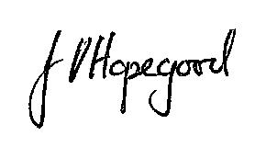

Mrs J Hopegood
Head Teacher

---------------------------------------------------------------------------------------------------------------------------------

CONSENT FORM FOR THE USE OF BIOMETRIC INFORMATION IN SCHOOL

Please complete this form if you consent to your child using biometric systems until he/she leaves the school.

Once your child ceases to use the biometric recognition system, his/her biometric information will be securely and permanently deleted.

I give consent to the school for the biometrics of my child: _______________________________

In tutor group ______________________. To be used by Selwood Academy for use as part of a recognition system as described above.

I understand that I can withdraw this consent at any time in writing.

Name of Parent: …………………………………………………………………………..

Signature: ………………………………………………………………………

Date: ……………………

